**● Write SQL query to solve the problem given below:**

You need to use the sql commands to create the table given and to solve the problem given below.>

**create table users**

**(**

**year int(50),**

**subject varchar(50),**

**winner varchar(50) ,**

**country varchar(50) ,**

**category varchar(50)**

**);**

**INSERT INTO eg(year,subject,winner,country,category)VALUES('1970','physics','lois nill','france','scientist'),**

**('1970','physology','bernard','germany','scientist'),**

**('1970','litrature','paul','france','economist'),**

**('1987','economics','luis','usa','linguist'),**

**('1978','chemestry','donald','egypt','president'),**

**('1994','peace','mehul','france','president'),**

**('1987','physics','robot','japan','prime minister'),**

**('1994','litrature','anwar','egypt','president'),**

**('1978','peace','menacham','israil','economist')**

**● Write sql query to find the nobel prize winners of the year 1970. Return year,subject and winner.**

**>**SELECT * from eg where year =1970;

**● Write sql query to find the nobel prize winners in chemistry between the years 1970 and 1980. Begin and end values are includedReturn year, subject, winner and country.**

**>** SELECT*FROM eg WHERE year=1970 OR 1980;

**● Write sql query to retrieve the details of the winners whose first name matches with the string ‘Louis’. Return year,subject,winner,country.**

**>**SELECT * from eg where winner LIKE "lois%"

**● Write sql query to find Nobel prize winners for the subject that does not begin with the letter ‘P’. Order the result by year, descending and winner in ascending.**

**>**SELECT * from eg where subject NOT LIKE "p%" ORDER BY year DESC

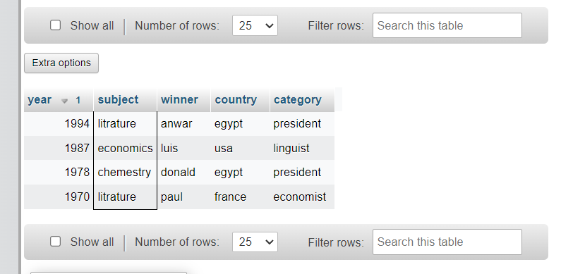

**● Write sql query to find the details of 1970 Nobel prize winners. Order the result by subject, ascending except for ‘Chemistry’ and ‘Economics’ which will come at the end of the result set. Return year, subject, winner , country and category.**

SELECT * from eg where year LIKE "1970" ORDER BY subject ASC

